## Front End Engineering-II

Project Report

Semester-IV (Batch-2022)

Drag and Drop

**Supervised By: Submitted By:**

Raveesh Samkaria [Saransh Sharma](mailto:SaranshSharmaji@gmail.com)

2210990797(G-12)

**Department of Computer Science and Engineering**

## Chitkara University Institute of Engineering & Technology,

## Chitkara University, Punjab

## ABSTRACT

The project will focus on developing a dynamic web application where users can interact with various elements through simple drag and drop gestures. Leveraging the versatility of Tailwind CSS, we will create visually appealing components and fluid layouts that adapt to different screen sizes and devices. Through a combination of HTML, CSS, and JavaScript, the project will explore the integration of drag and drop functionality, including features such as reordering items, uploading files, and organizing content. Through practical implementation and exploration of best practices, the project aims to empower developers to create engaging user experiences that elevate their web applications to new heights of usability and interactivity.

**1.1 INTRODUCTION**

Drag and drop interfaces empower users to manipulate digital content effortlessly, mimicking real-world interactions and streamlining complex tasks. Whether it's rearranging elements, uploading files, or organizing data, drag and drop functionality offers a seamless and intuitive user experience that enhances productivity and satisfaction.

**1.1 BACKGROUND**

The concept of drag and drop traces its roots back to desktop computing, where users could drag files and folders to different locations within the file system. This simple yet effective interaction pattern has since found its way into web development, enabling developers to create dynamic and responsive interfaces that facilitate seamless content manipulation.

**1.2 OBJECTIVE**

The primary objective of this project is to develop a dynamic web application with drag and drop functionality using Tailwind CSS, aimed at enhancing user experience and usability. Specifically, the project aims to achieve the following objectives:

Implement drag and drop interactions: Develop functionality that allows users to drag elements within the interface and drop them in predefined areas.

Integrate tailwind CSS styling: Utilize Tailwind CSS to style the interface, creating visually appealing components and layouts.

Responsive design: Ensure that the application is responsive and adapts seamlessly to different screen sizes and devices.

Enhance user experience: Focus on enhancing the overall user experience by implementing intuitive interactions and providing feedback for user actions.

**1.3 SIGNIFICANCE**

This project holds significant importance in the realm of web development for several reasons: enhanced user experience, efficiency and productivity, accessibility, visual appeal and branding, learning opportunity, innovation and differentiation this project not only showcases the capabilities of drag and drop interfaces and Tailwind CSS but also underscores their significance in creating modern, responsive, and user-friendly web applications.

**2.PROBLEM DEFINITION**

The specific problem addressed by this project is the lack of intuitive and efficient methods for manipulating digital content within web applications. Traditional interfaces often require users to navigate through multiple steps or perform repetitive actions, leading to frustration and decreased productivity. Additionally, the limited responsiveness and visual appeal of many web applications hinder engagement and user satisfaction.

**3.REQUIREMENTS**

These requirements span various aspects of the project, including functionality, design, and user experience.

1. Drag and drop functionality: The application must allow users to drag elements within the interface and drop them into designated areas.

2. Tailwind CSS integration: All styling for the application must be implemented using Tailwind CSS.

3. Responsive design: The application must be responsive and adapt seamlessly to various screen sizes and devices.

4. Accessibility: Ensure that the application is accessible to users with disabilities by implementing keyboard navigation and other accessibility features.

5. Documentation: Document the process of implementing drag and drop functionality using Tailwind CSS, including best practices, tips, and techniques.

6.Testing: Conduct thorough testing of the application to ensure that drag and drop functionality works as expected across different browsers and devices.

By meeting these requirements, the application will provide users with an intuitive and efficient way to manipulate digital content, while also showcasing the capabilities of Tailwind CSS in creating modern and responsive user interfaces.

**4.PROPOSED DESIGN**

Proposed design for drag and drop:

1. User interface layout: The application will feature a clean and minimalist design, with a focus on usability and intuitive navigation.

2. Draggable elements: Key elements within the interface, such as cards or files, will be made draggable using HTML5 drag and drop API.

3. Drop zones: Designated drop zones will be defined within the interface where users can drop draggable elements.

4. Customization options: Users may have the option to customize the appearance of draggable elements and drop zones, such as changing colours or adding custom icons.

5. Accessibility Features:: Accessibility features will be incorporated to ensure that the application is usable for all users, including those with disabilities.

By following this proposed design, the application will offer a seamless and intuitive drag and drop experience, while also prioritizing usability, accessibility, and responsiveness.

**5. FILE STRUCTURE**

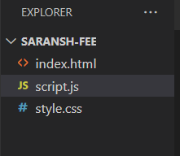

**5.1 HTML CODE**

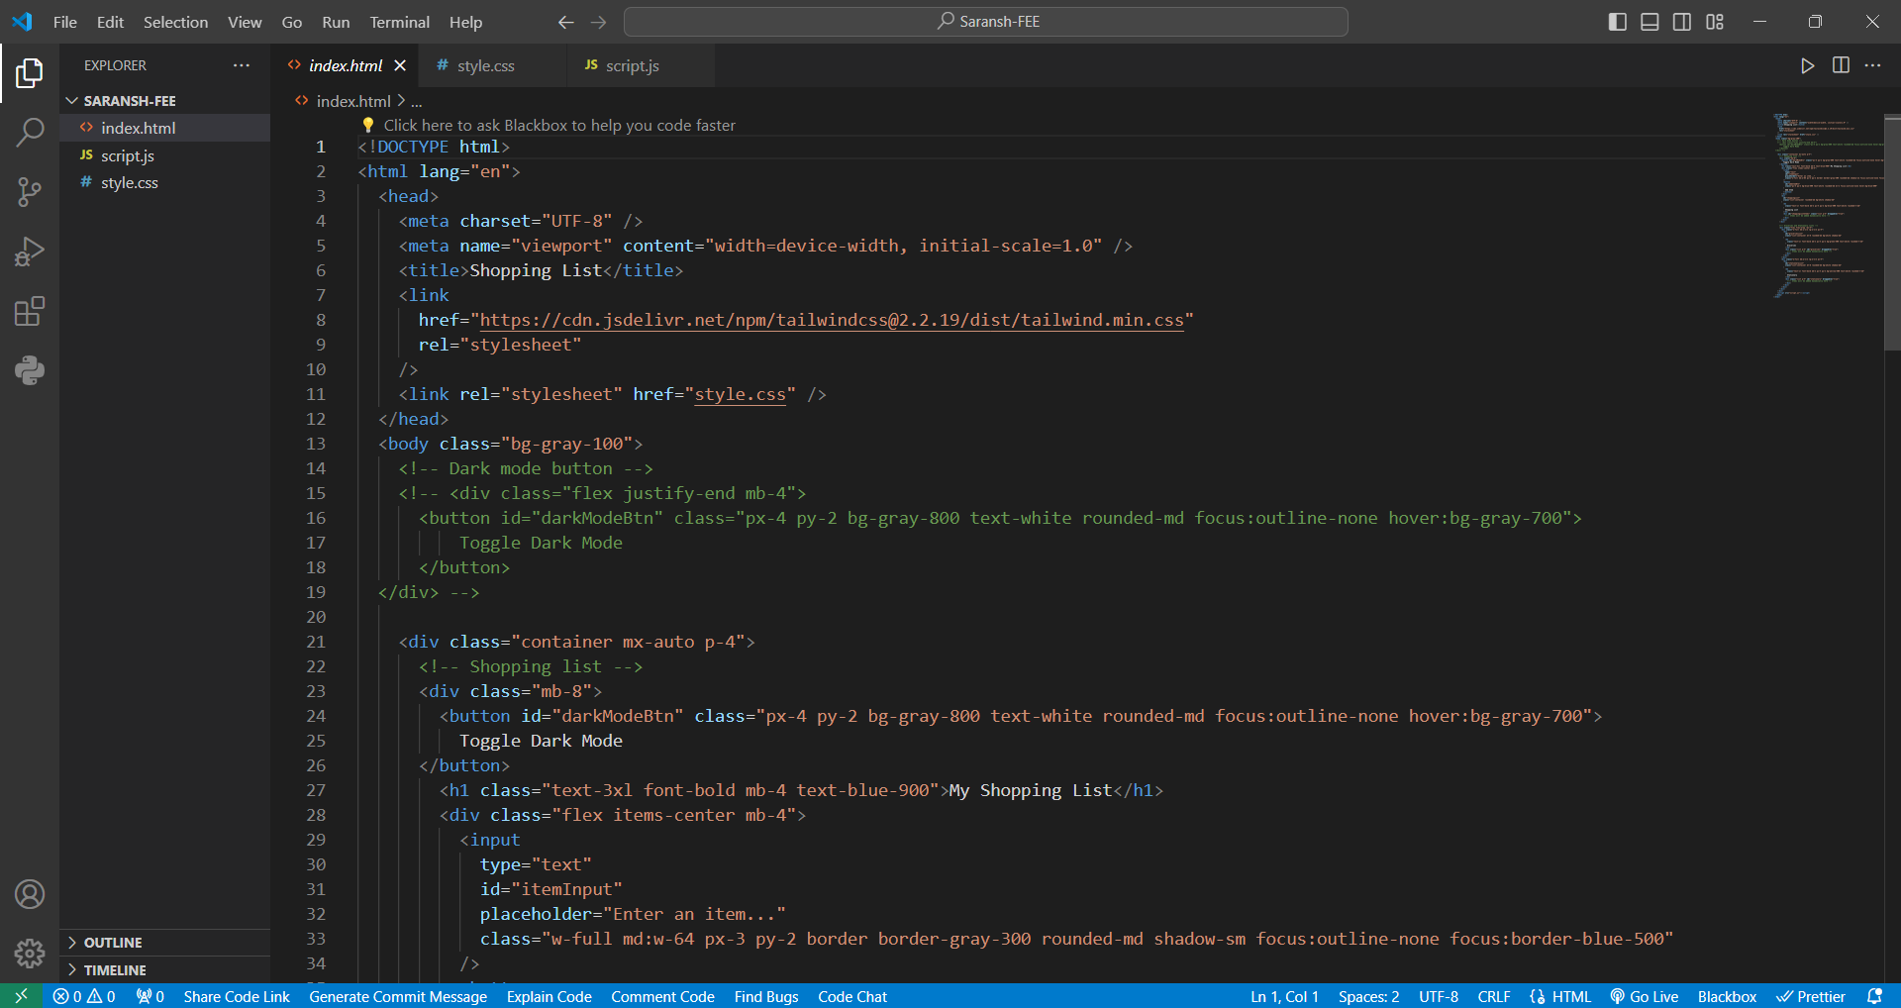

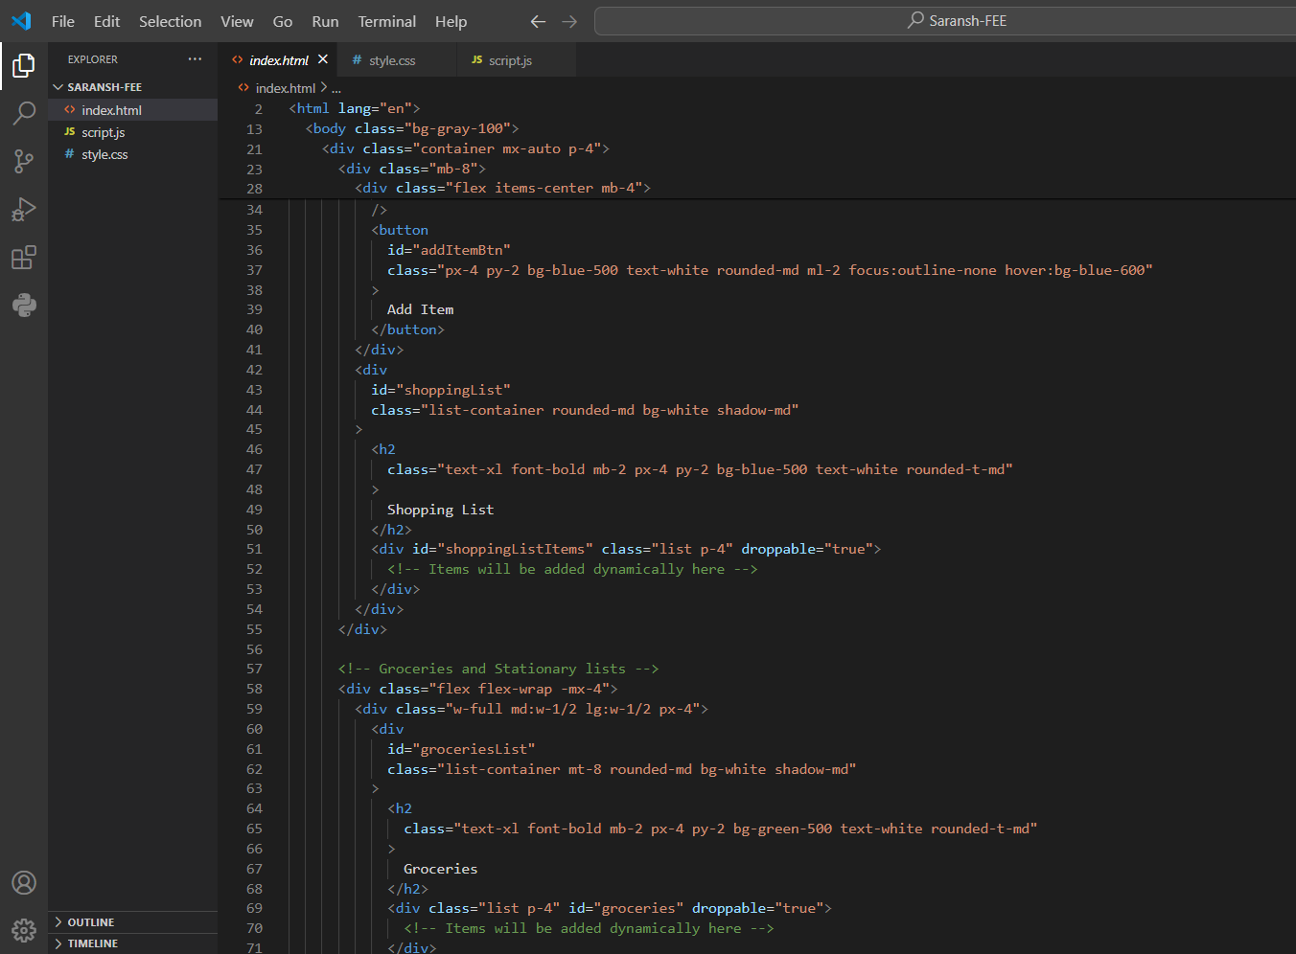

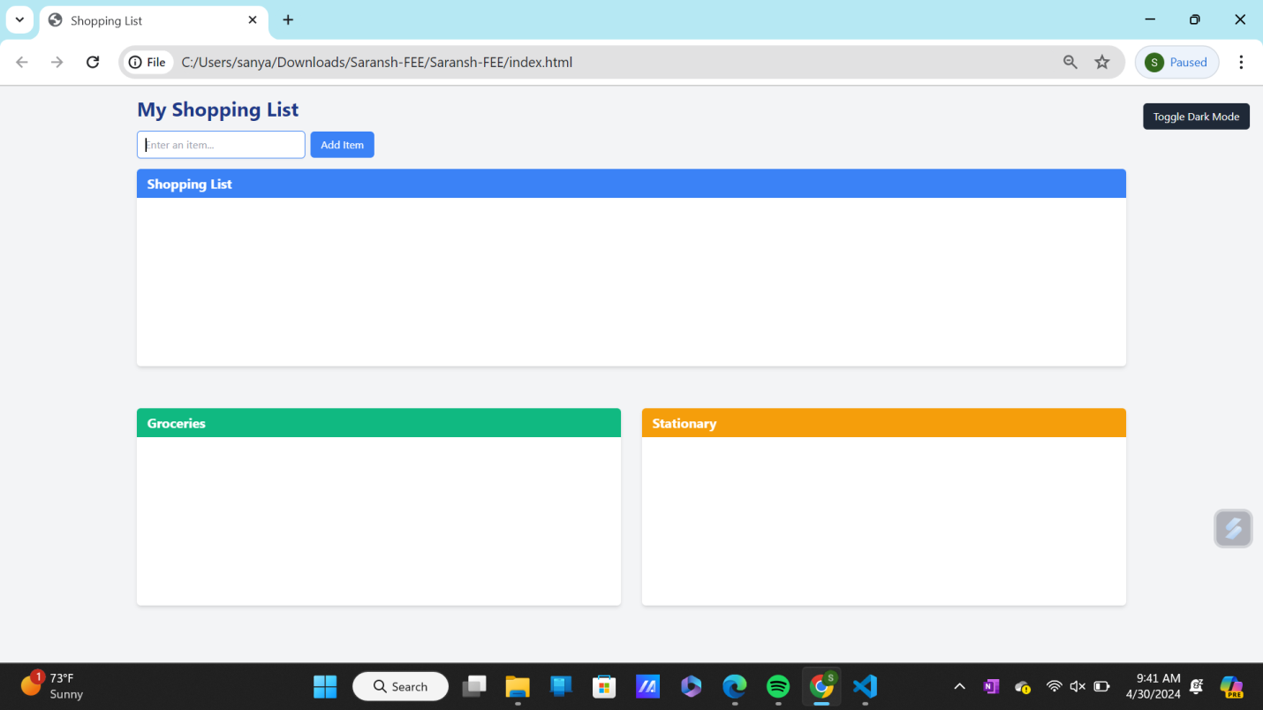

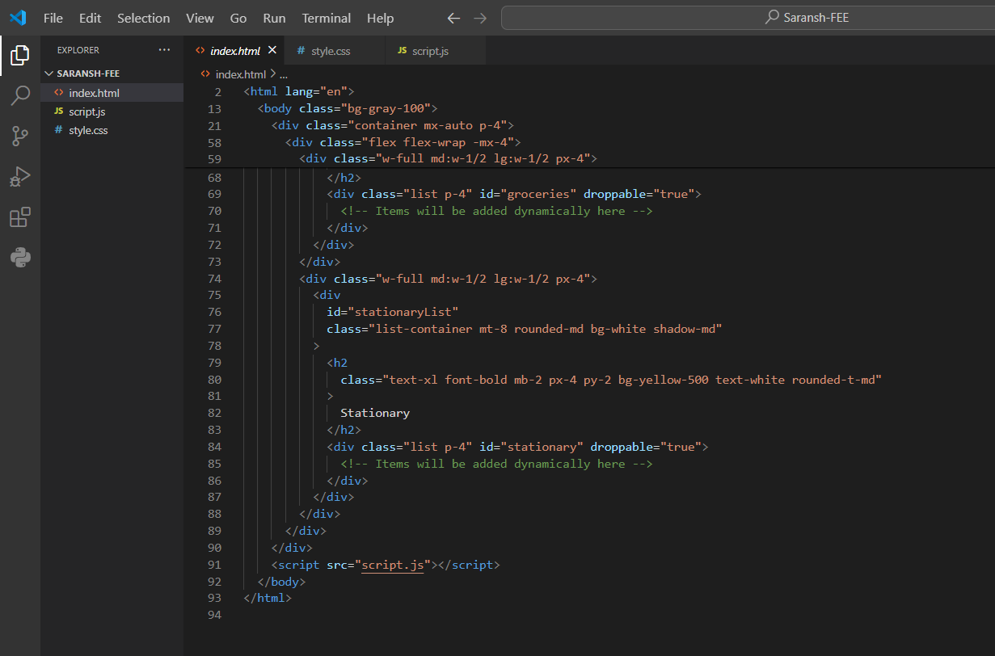

**5.2 TAILWIND CODE**

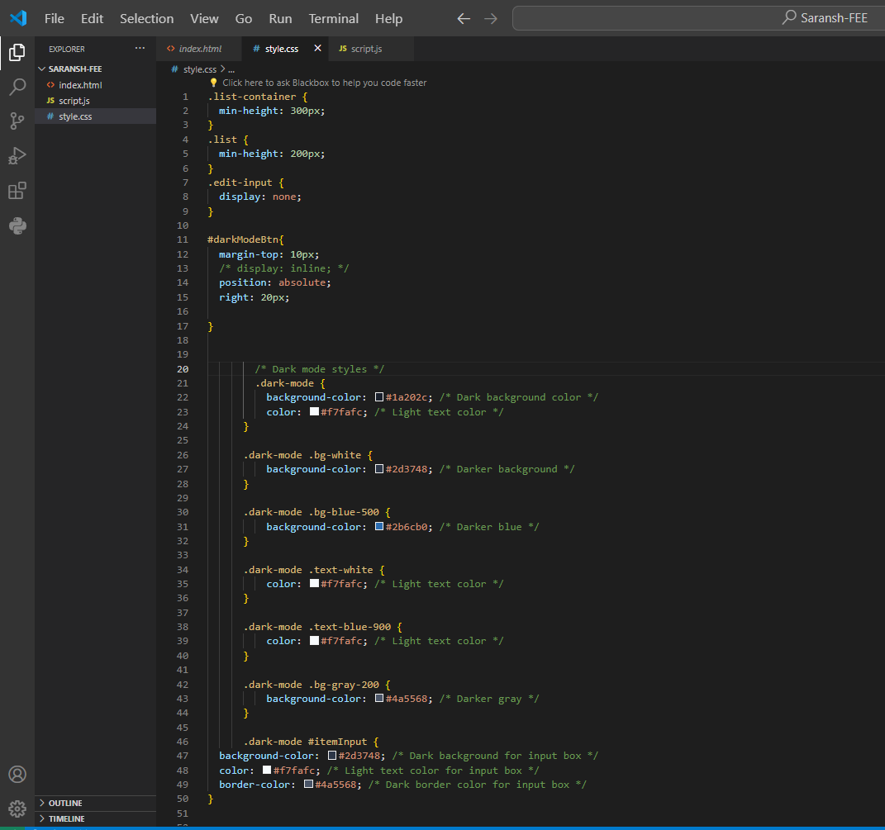

**5.3 JAVASCRIPT CODE**

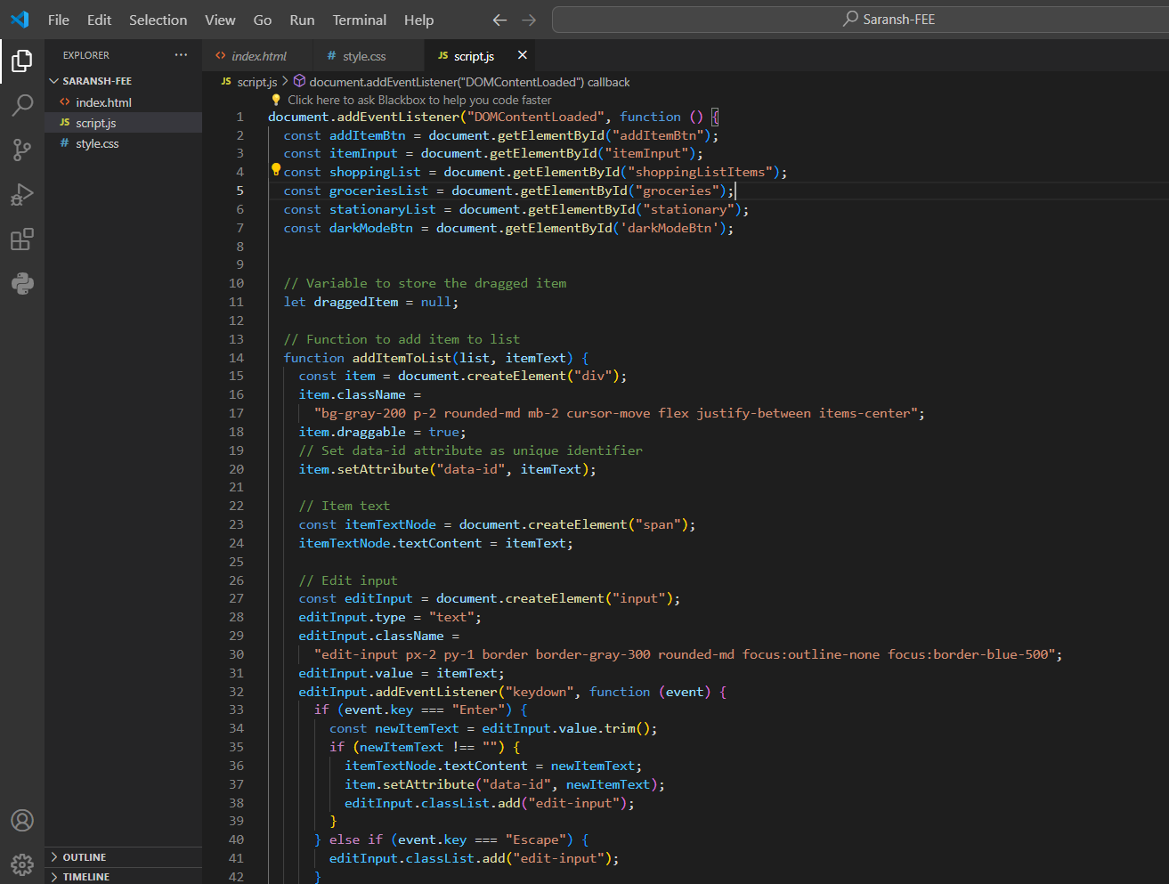

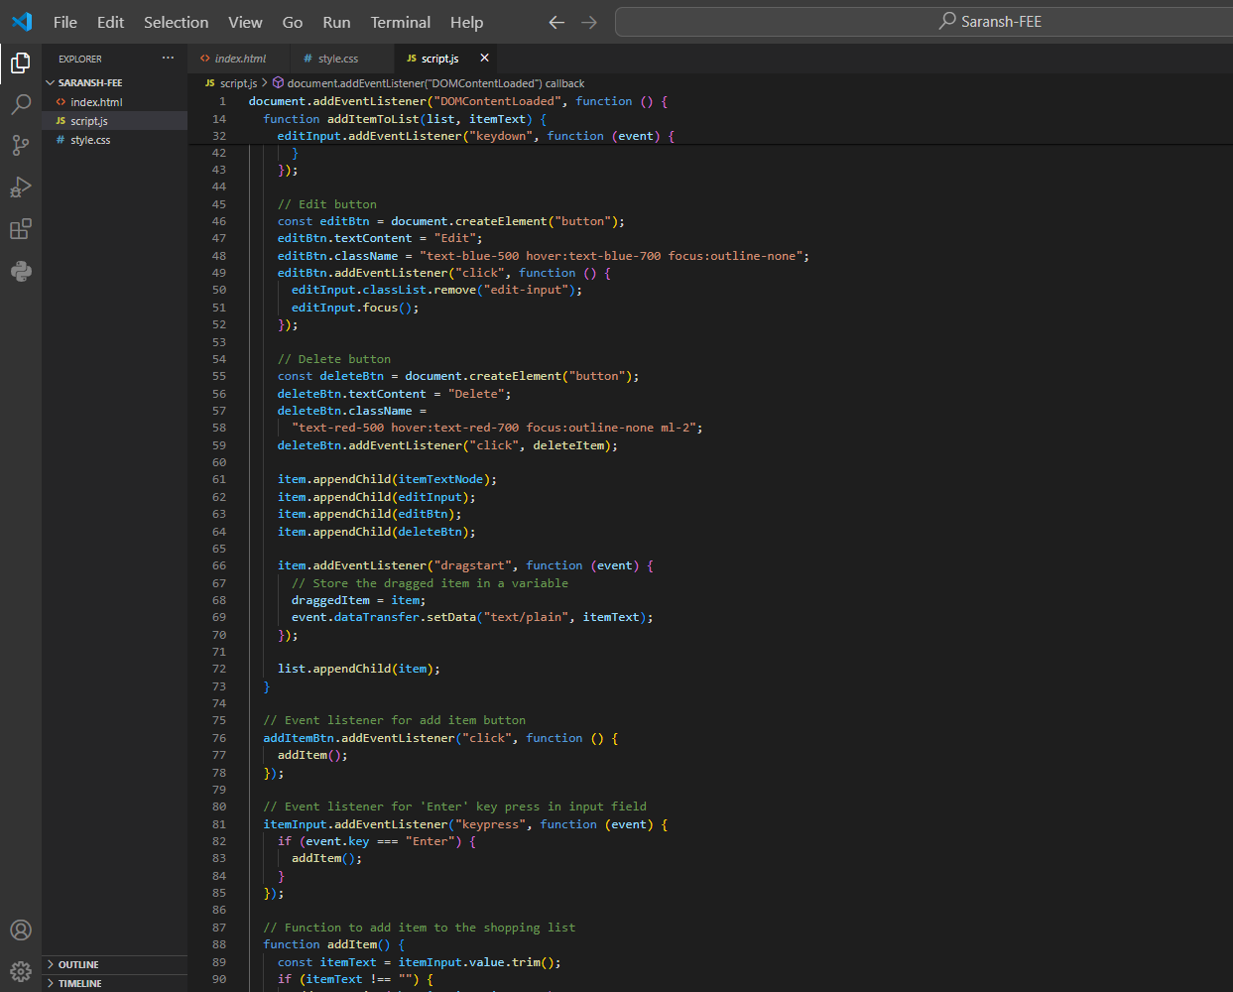

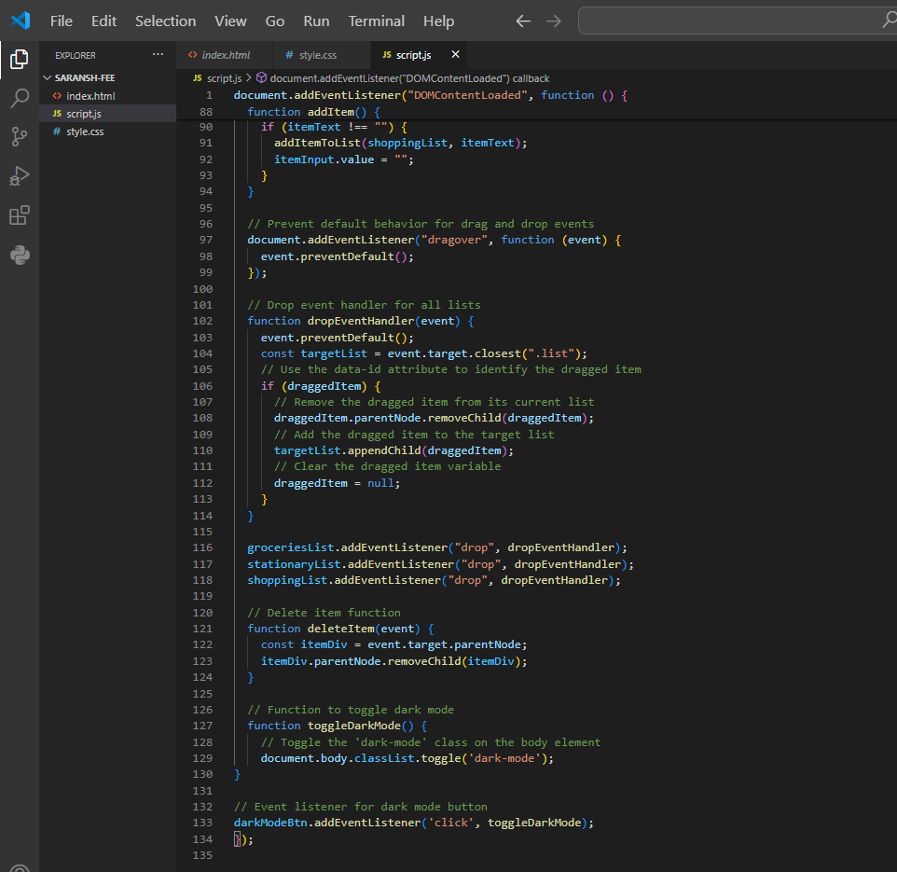

**6.RESULTS:**

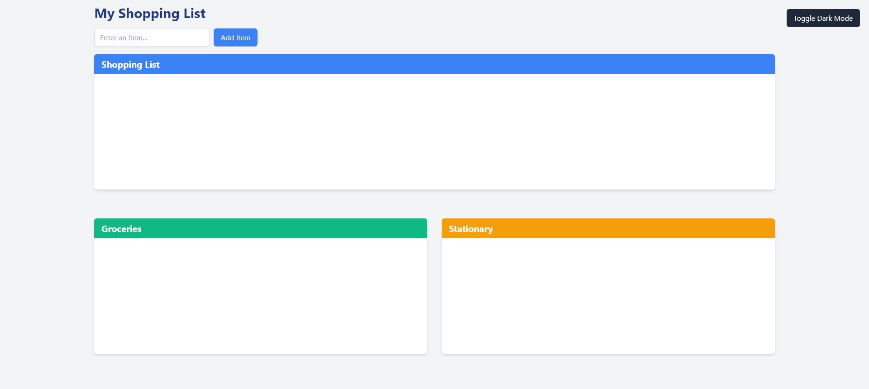

Light mode

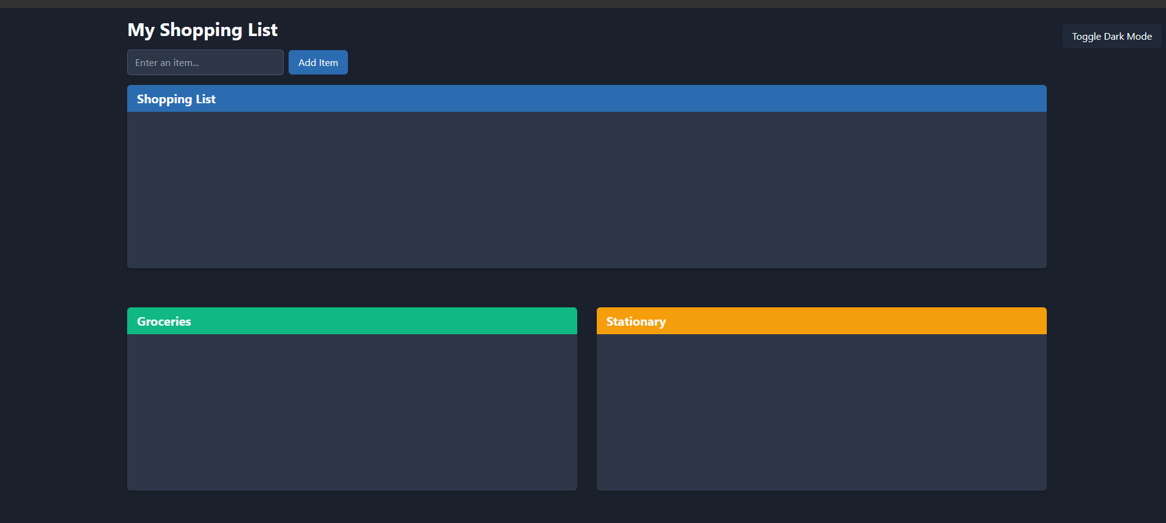

Dark mode

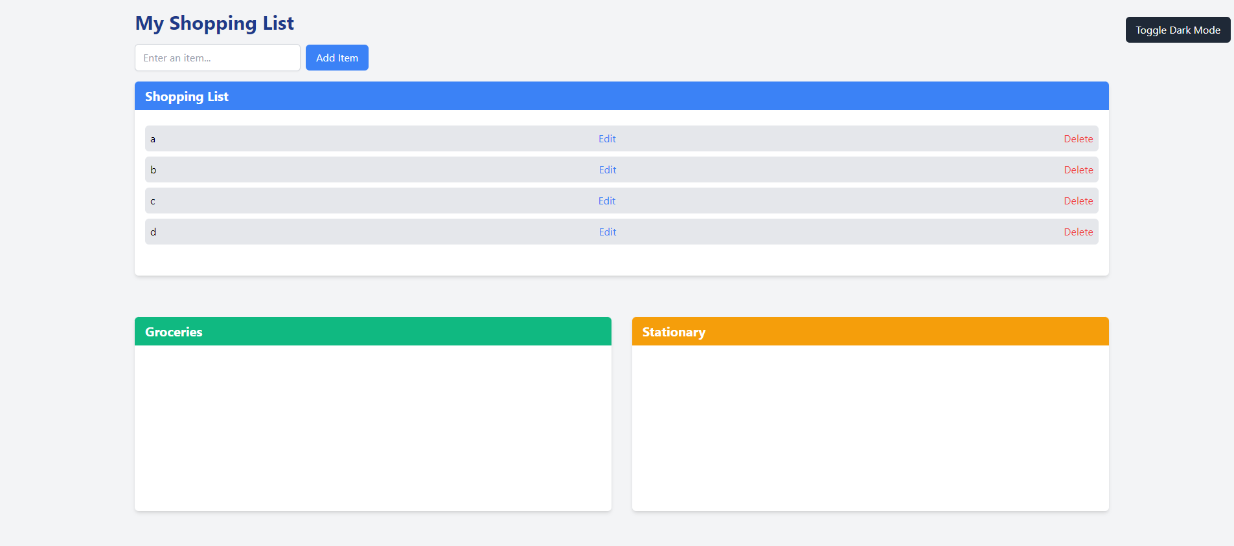

Adding items to the list

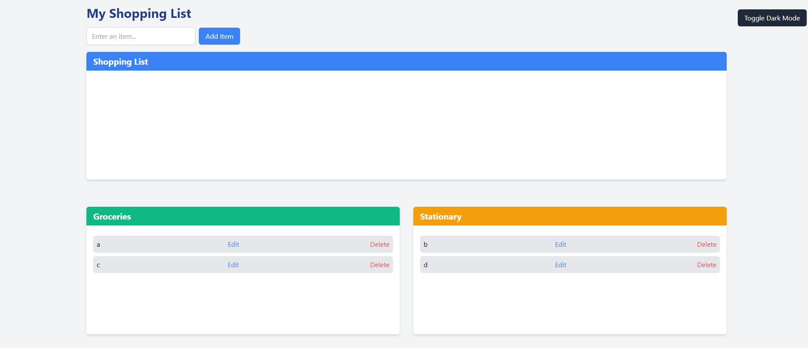

Drag and drop the items according to groceries and stationaries

**7. REFERENCES**

Here are some references that can be useful for implementing drag and drop functionality using Tailwind CSS:

1. Tailwind CSS documentation: The official documentation for Tailwind CSS provides comprehensive guidance on using utility classes, responsive design, and customizing styles.

2.HTML5 :Understanding the fundamentals of the HTML5 Drag and Drop API is essential for implementing drag and drop functionality.

3..Tailwind UI: Tailwind UI offers a collection of pre-designed components and templates built with Tailwind CSS.

4. Javascript: JavaScript documentation serves as a reference for understanding the language features, APIs, and best practices. Resources like the Mozilla Developer Network (MDN) provide comprehensive documentation on JavaScript.

These references should provide a solid foundation for implementing drag and drop functionality using Tailwind CSS, whether you're working with vanilla JavaScript, or other frameworks.